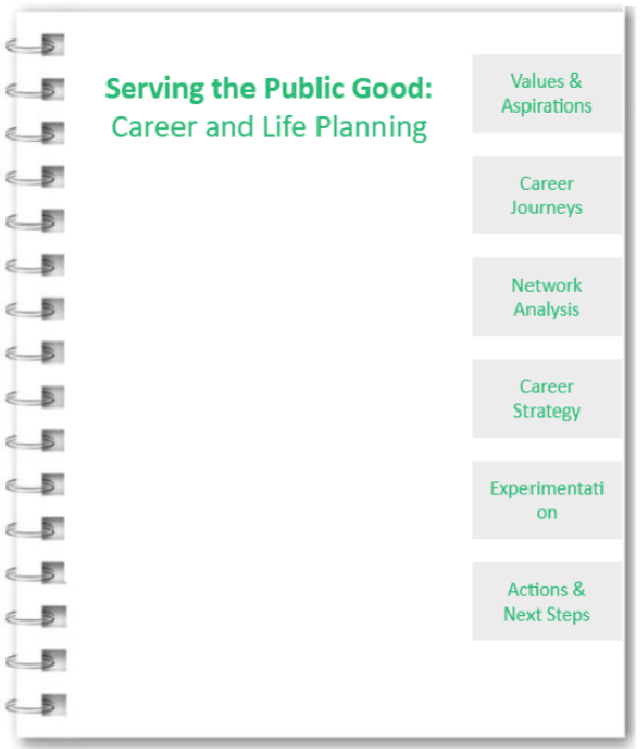

Class 2 Assignment: Values & Aspirations

a) Work View and Life View
Please read pg. 31-38 in Designing Your Life for background. To recap, a workview addresses the critical issues related to what work is and what it means to you, while a lifeview is simply your ideas about the world and how it works. Next, fill out the section below with your work and life view.
- What is work for?  - Why do you do it?  - What makes work good?  - How does it relate to others in society?  - How important are experience, growth, and fulfillment through work? | Work View

- What gives life meaning?  - What makes your life worthwhile or valuable?  - How does your life relate to others in your community?  - What do money, fame, and personal accomplishment mean to you? | Life View

b) What you think the world needs the most
Think about what you think the world needs the most. If you’re feeling lost, read the 80,000 hours Problem Framework and reflect below. For a list of ideas, visit the 80000hours.org List of Pressing World Problems
- What problems do you think are most critical right now?  - How would you like to make an impact on the world?  - If you could instantly eliminate one issue, what would it be? | What does the world need the most?

c) What are you good at
- How have people described your key strengths?  - How have people described your key areas of development?  - If you were to play to your top 2-3 strengths, what would they be? | What are you good at?

d) Risk Tolerance
Please reflect on how comfortable you feel navigating uncertainty and ambiguity in your career.
- Do you often feel regret?  - How long can you be unemployed without feeling uncomfortable?  - Would you sacrifice well-being in the short term for potential well-being in the long term? What about income?  - How do you feel about moving somewhere unfamiliar?  - How do you feel about temporary positions or uncertain next steps?  - How do you feel about others close to being impacted by your decisions? | Risk Tolerance

💡OUTPUT: Your Overall Guiding Values and Strengths
Please write a few sentences on your overall guiding values, strengths based on what you learned in the Work & Life View, What the world needs the most, Career Values, and Risk Tolerance exercises. You will refer back to this later in the workbook.
Your Overall Guiding Values and Strengths

Class 2: Possible Career Journeys

a) Career Anchors
Career Anchors is a diagnostic tool developed by Edgar Schein that allows you to determine your values and what is important to you in your career. There are eight career anchors. Your results give you a window into what you are good at, what you value, and what motivates you.
Please click this link and do the career anchors exercise. This is a Canvas link that will enable the download of the book chapter. Please read the short book chapter and do the assessment. You might even want to print the pages if you want. At the end of the chapter, you will find a description of the categories.
Your career anchor scores:
Life Style
Pure Challenge
General Managerial Competence
Security/Stability
Technical/Functional Competence
Autonomy/Independence
Entrepreneurial Creativity
Service/Dedication to a Cause

b) Career Odyssey Planning
Odyssey Planning is an exercise by Bill Burnett & Dave Evans that involves creating three different versions of the next five years of your life. Please read pg. 90-103 in Designing Your Life for instructions on this exercise. Thereafter, create your three Career Odyssey plans using the template linked here from the book. Note: it may be easier to print the page and do the exercise by hand.
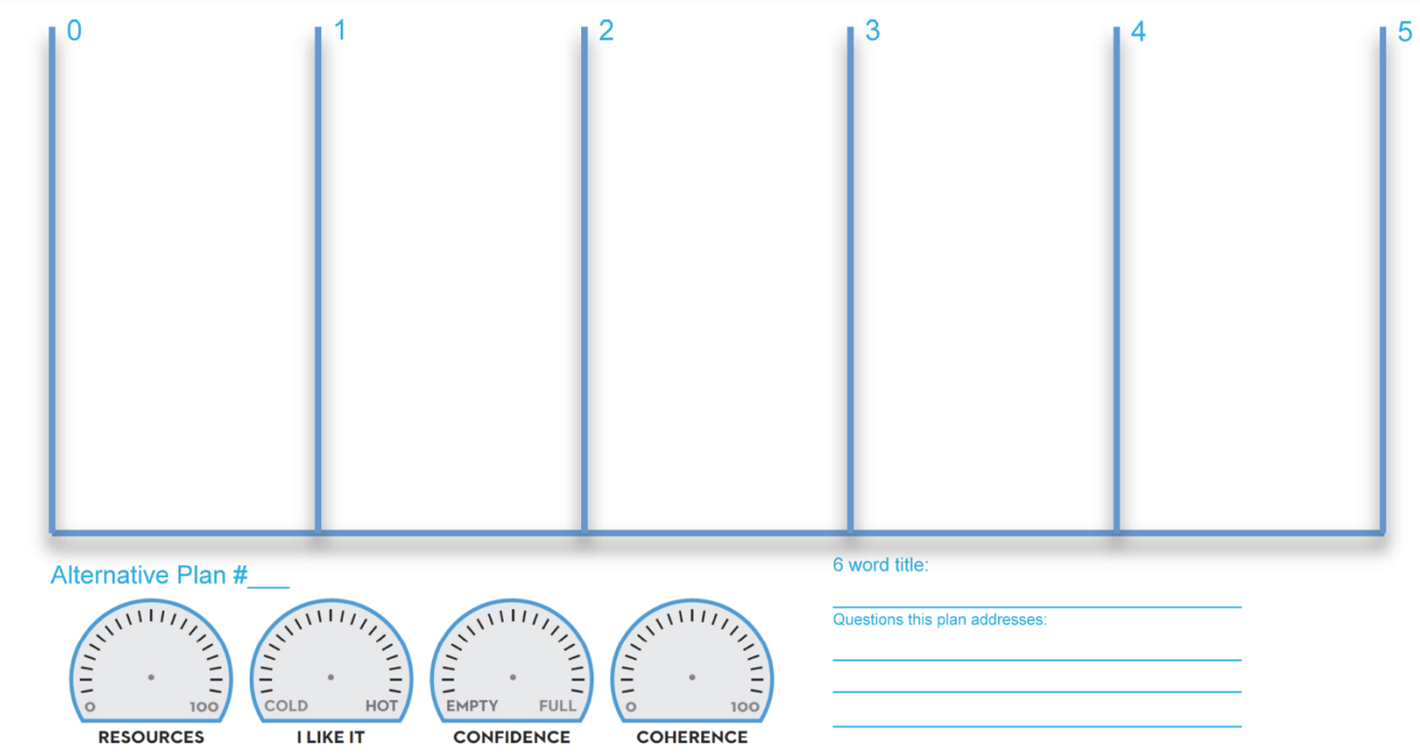

c) Option Evaluation
We will use the three Career Odyssey plans from step b above and reflect on the options. Do you know enough yet to narrow down these choices? If not, this semester is a chance to refine your understanding of yourself and your options.

- Can you combine any of the three potential odysseys creatively, even if they are in slightly different forms?  - Is there a natural sequencing of these where you can do multiple options at different times?  - Going back to your values and north star, what speaks to you?  - Are you willing to take risks? | Option Evaluation

💡OUTPUT: Moving Forward Hypothesis
Do you have a clear view which of the three Career Odyssey plans you will move forward with? If not, which one(s) will you explore further in this course? It’s OK to not be sure, this is an iterative process!
Write down which career odyssey(s) you think you might want to focus on at present in this course:

Career Odyssey to Explore Further at Present:

Class 3: Networking and Career Learning

Practicing Networking: HKS Alumni Interviews
One of the assignments in our class is to interview 3 HKS alumni and learn about their career journeys. Here is a list of potential questions you can use:

  - Tell me about the job, what does it really mean?
  - What do you like about it?
  - What frustrates you?
  - How did you get to this job? What was the sequencing? What skills and network levers were required?
  - What advice would you give me if I were interested in a role like this?
  - Are there other similar roles that would also be interesting?
  - Who else can I talk to to learn more?
  - What’s the career path after this role?
  - What are the financial and work-life balance impacts of this job?
  - As a student at HKS what could I be doing?

Please write down the names of the 3 alumni you interviewed and a summary of what you learned:
 | Alumni Interview Insights
 | Name | Key Insights

Your 3 Network Contact interviews (return here when you do it)
Please write down the names of the 3 network contacts you interviewed and what you learned:
 | Network Contact Interview Insights
 | Name | Key Insights
a) Networking Goals
Now, please identify three professional goals you’d like to achieve through networking (example: Find a potential co-founder, learn tips for how to manage family and work).
Networking Goals
Goal 1
Goal 2
Goal 3

b) Strong Tie Network
Please enter up to 15 names of people from your existing personal and professional network that could help you learn more about or move towards the above goals. Write a list for each goal. Make sure it’s specific people’s names, not groups or associations!
Tip: Strong Tie connections are different from Weak Tie connections in that you have an existing relationship with them and you would say they know you beyond just an acquaintance level.
Personal Contacts List (e.g. friends, relatives)
 | Goal 1 | Goal 2 | Goal 3
Names of individuals
Professional Contacts List (e.g. coworkers, managers, former clients)

c) Weak Tie Network
Make a list of up to 5 potential networks, groups, associations, etc that you can explore for each goal to meet new individuals (example: Harvard alumni association).
New Networks to Explore
 | Goal 1 | Goal 2 | Goal 3
Names of specific networks, groups, associations, etc. to explore

💡OUTPUT: Moving Forward Hypothesis
Now, let’s make a commitment to grow your networks! Write down what concrete steps you will take to cultivate your strong and weak tie networks this semester:

Individuals you will reach out to:
Steps you will take to cultivate new networks:

Class 3: Career Strategy

a) Knowhow Gaps
Please refer back to your Career Odyssey templates from section 2.
List 2-4 types of knowledge you will need in your future career (or multiple career path options), and identify the time horizon for acquiring the knowledge as well as how urgent and important it is for you to address these gaps in knowhow.

Knowhow Gaps
 | Knowledge  Needed | Time Horizon  (in years) | Current Proficiency (1-10) | Desired Proficiency (1-10)

Knowhow Development Plan
Brainstorm options for how to develop competency in each of the above areas. Make a plan for each number you wrote above - can you take a class at HKS? Take on a side-project? Read a book?

Knowhow Development Plan
1.
2.
3.
4.
5.

b) Life Factors
What life factors might impact your career plans, positively or negatively? How can you proactively take steps to mitigate any negative effects and achieve a balance with your career goals?

Life Factors
- How might your personal goals and interests be impacted by your career plans?
- How might your family be impacted by your career plans?
- How is your wellbeing now and how might it be impacted by your career plans?
- How much risk and disruption can you take right now? Why?

c) Roadblock Analysis
What roadblocks do you anticipate encountering on your future career path? How strongly might this impact your plans? How can you proactively take steps to mitigate any negative effects?

Possible Roadblocks
 | Roadblock  (Example: Upward mobility requires relocating to the headquarters) | Potential Impact | Mitigation Strategies
1.
2.
3.

Class 4: Experimentation

Experimentation in career planning involves testing out a direction or environment to gather data on how it feels to you before fully committing. Use the template below to lay out your thoughts on two experiments you can try out this year (e.g., interning at the UN, writing for student newspaper).
Experiment 1 Name:__________________________
What are you hoping to find out?
Where are you going in order to learn more?
What are you doing there?
How much time will you commit? (e.g. summer break, 4 hours a week)

Experiment 2 Name:__________________________
What are you hoping to find out?
Where are you going in order to learn more?
What are you doing there?
How much time will you commit? (e.g. summer break, 4 hours a week)

Class 6: Next Steps/Actions

Reflect on 2-3 things you will do differently based on the course:

Things to do differently

Please review the learnings in the section below. What can you commit to DOING NOW?
(E.g. attend a coaching session, browse LinkedIn, take a class)

Specific actions to take in the next 6 months
Action 1
Action 2
Action 3
Action 4
Action 5

Workbook Material References:
- Burnett, B., & Evans, D. (2016). Designing Your Life: How to Build a Well-Lived, Joyful Life (Illustrated ed.). Knopf.
- Schein, E. H., & Maanen, V. J. (2013). Career Anchors: The Changing Nature of Careers Self Assessment (4th ed.). Pfeiffer.
- Ibarra, H. (2004). Working Identity: Unconventional Strategies for Reinventing Your Career. Harvard Business School Press.
- Knowdell Career Planner, Career Values Sorting Exercise https://www.careerplanner.com/index.cfm
- Lyubomirsky, S. (2013). The how of happiness: A practical guide to getting the life you want. Piatkus Books.
- Seligman, M. E. P. (2012). Flourish: A visionary new understanding of happiness and well-being. Atria Books.
- Todd, B. (2022, July 7). A framework for comparing global problems in terms of expected impact. 80,000 Hours.
Retrieved July 26, 2022, from https://80000hours.org/articles/problem-framework/
- Todd, B. (2022, July 7). What are the most pressing world problems? 80,000 Hours.
Retrieved July 26, 2022, from https://80000hours.org/problem-profiles/

